Костанайский государственный педагогический институт
Филологический факультет
Кафедра иностранных языков

Унгутбаева Г.Ш.

КУРС ЛЕКЦИЙ ПО СТРАНОВЕДЕНИЮ
С ПРАКТИЧЕСКИМИ ЗАДАНИЯМИ

Костанай 2017
УДК 80\81(0758)
ББК 81.2 - 923
У58

Автор:
Унгутбаева Г.Ш., старший преподаватель кафедры иностранных языков.

Рецензенты:
Кудрицкая М.И., к.п.н., доцент, заведующая кафедрой иностранных языков КГПИ
Морозова Д.А., к.п.н., доцент, заведующая кафедрой филологии КФ ФГБОУ ВО «ЧелГУ»

Унгутбаева Г.Ш.
У58 Курс лекций по страноведению с практическими заданиями: учебно-методическое пособие / Г.Ш. Унгутбаева. – Костанай: КГПИ, 2017. – 56 с.

ISBN 978-601-7839-67-3

Настоящее пособие разработано для студентов и магистрантов филологического факультета, изучающих курс «Страноведение», и имеет целью сформировать межкультурную и когнитивную компетенции, необходимые для профессионального владения иностранными языками как средством общения.
УДК 80\81(0758)
ББК 81.2 -923

Рекомендовано к публикации решением Ученого Совета Костанайского государственного педагогического института

ISBN 978-601-7839-67-3

© Костанайский государственный
педагогическийинститут,2017

Contents

Introduction……………………………………………………………….4
Thematic сurriculum.……………………………………………………..5
Lecture 1.Geography of the UK………………………………………….7
Lecture2. British History…………………………………………………10
Lecture3. The population of the UK……………………………………..13
Lecture4. The system of government in the UK………………................18
Lecture 5. Economy of the UK…………………………………..............21
Lecture 6. Education of the UK………………………………………….26
Lecture7.Arts and mass media in the UK………………………………..29
Lecture 8.Geographic outline of the USA………………………………..33

Lecture 9.Main historic events of the USA………………………………37

Lecture 10.The population of the USA…………………………………..41

Lecture 11. The system of government of the USA……………………...43
Lecture 12.Economy of the USA………………………………………...46
Lecture 13 .Education in the USA………………………………………..48
Lecture 14. American Arts……………………………………………….52
Lecture 15. American mass media……………………………………….53
References………………………………………………………………..55

Introduction

Mastering of national cultural and historical values includes realization of harmony international, common to all mankind and nationalities, i.e. requires also opening of cultural achievements of other people and capture by them. This work supposes the psycho-pedagogical culture of teacher of foreign language, good knowledge of the age-related psychological features of students, abilities to use educator’s potential of maintenance of educational material on employment.
In the process of study of country-specific studies cognitive, teaching, socially-therapeutic, adaptation, developing functions of education will be realized in their unity.
Country-specific studies, assisting the mutual enriching of national cultures, help easier and deeper to perceive common to all mankind through studying national values. It enriches the student’s thesaurus with relevant vocabulary, terminology, phraseology, introduces such a notion as culture-oriented linguistics.
This text edition is devoted to the USA and the UK. You will be able to learn more about the history of these countries, peculiarities of the systems of government and education, about famous artists and art schools. Besides that this text edition contains some additional exercises to each theme, which can be helpful for students to perceive new information.

Thematicplanningonthepractical course of сountrystudies

№ | Theme of the lecture | Theme of seminars | Hours | Dates
1 | Geography of the UK. | British rivers, their direction and character | 2 | 1stweek
2 | British history | Be ready with information about the revolt of Queen Boadicea | 2 | 2ndweek
3 | Population of the UK | English households.Cohabitation | 2 | 3rdweek
4 | The system of the government in the UK | “Iron Lady” M. Thatcher, the first woman prime -minister | 2 | 4th week
5 | Economy of the UK | Talk about woolen industry of the UK | 2 | 5thweek
6 | Education in the UK | Be ready with information about tutorial system of education in Oxbridge | 2 | 6thweek
7 | Arts in the UK | Famous artists of the UK. Be ready to talk about famous paintings | 2 | 7thweek
8 | Geography of the USA | Find information about Great Lakes, their importance in the economic life of the USA. | 2 | 8thweek
9 | History of the USA | Be ready to talk about Negro Slavery in America.A.Lincoln-the 16th president of the USA | 2 | 9thweek
10 | Population of the USA | Find additional information about Native Americans and origin of some place names in NorthAmerica | 2 | 10thweek
11 | Governmental system of the USA | Electoral system of the USA.Be ready to talk about results of Elections 2016 | 2 | 11th week
12 | Economy of the USA | Be ready to discuss agricultural region of the USA | 2 | 12thweek
13 | Education in the USA | Higher educational institutions in the USA,public and private,the quality of education in them | 2 | 13thweek
14 | American arts | Be ready to talk about two schools of painting in America: Hudson River school and Ash Can School | 2 | 14thweek
15 | American mass media | American television.Famous Newscasters | 2 | 15thweek
 | Total: |  | 30 hours

Lecture 1
Geography of the UK.

Goals:
to give students basic information about the subject they are going to learn about;
to inform students about the geographical position of the UK;
to enrich the students outlook
Students will be able:
1 to get some additional information about thenotions:GreatBritain,the UK of Great Britain and Northern Ireland
2 to talk about peculiarities of climate,relief
3 to discuss characteristics of mineral resources
The UK of GB and NI consists of 4 main parts: England, Scotland, Wales and Northern Ireland. It’s area is 244,100 square km. The UK is situated off the west coast of Europe between the Atlantic Ocean and the North Sea and is separated from the European continent by the English Channel and the Strait of Dover.
The island of GB is subdivided into 2 main regions: Lowland Britain and Highland Britain. The Pennine Chain extends southward from the Cheviot Hills into the Midlands, a plain region with low hills and valleys.
Scotland includes such islands as: the Hebrides, the Orkney, the Shetland islands.

Scotland

The Southern Uplands
The Northern Uplands
The Highlands
( Ben Nevis-1343m)

Wales

Cambrian mountains
(Snowdonia)
Cornwell peninsula
(pride of Wales)

Northern Ireland

Lough Neagh
Mournemountains

The chief rivers of GB are: the Severn, the Thames, the Clyde, the Dee, the Shannon, the Spey and the Tweed. On the north-west side of the Pennine system lies the Lake District.
Oak, elm, ash and beech are the commonest trees in England, while Scotland has much pine and birch. A wide choice of animals such as: mammals, foxes, otters, seals, rats and others can be found in the UK.
The climate in the UK is mild and temperate due to the influence of the Gulf Stream. January and February are the coldest months, July and August are the warmest.

Questions:
1What parts does the UK consisit of?
2 The area of the UK is..
3What is the UK washed by?
4What influences the climate of the UK?
5What mineral resources are mined in the UK?
6What are the chief rivers of theUK?
7What are national symbols of the UK?

Tasks:
Read the text about the United Kingdom and do the tasks:
The official name of the country we usually call «England» and occasionally «Great Britain» is the United Kingdom of Great Britain and Northern Ireland. The United Kingdom is situated on the group of islands lying just off the mainland of north-western Europe. The British Isles include Great Britain, Ireland and a number of smaller islands. The total area of the British Isles is 325000 square km.
Many ages ago the British Isles formed a part of the continent. The rocky highlands of Scotland, for example, resemble the Norwegian coast. Another evidence that the islands were the part of the continent is the shallow ness of the water between them and the mainland.
Now Great Britain is separated from the continent by the English Channel, the narrowest part of which is called the Strait of Dover. The British Isles are surrounded by the shallow waters of the Irish Sea and the North Sea, the Norwegian Sea, the North Channel and the Atlantic Ocean.
There are wild desolate mountains in the northern Highlands of Scotland. The Pennine Range in northern England and the Cambrian Mountains in Wales are much lower.
The rivers of the region are short and of no great importance as waterways. The longest of them is «the Father of London», the Thames, which is a little over 200 miles. Britain’s principal ports are London, Liverpool, Manchester and Glasgow. They have splendid harbours, for the coast line is very indented. Owing to the shape of the country, any point in Great Britain is no more than 70 miles from the sea.

"True" or" False"?
1. The official name of the country is Great Britain.
2. The United Kingdom is situated on the mainland.
3. Great Britain is separated from the continent by the English Channel.
4. The total area of the British Isles is 250000 square km.
5. The British Isles are surrounded by the Irish Sea and the North Sea.
6. The rivers of the region are short and ice-free
7. The main ports of Britain are London, Liverpool, Manchester and Glasgow
Lecture 2
The British history.
Goals:
to give students basic information about the subject they are going to learn about
to inform students about the history of the UK
Students will be able:
1 to get some information about Celtic tribes
2 to get acquainted with contribution which was made to British culture by Roman conquest, Anglo-saxon invasion, Scandinavian invasion
3 to get some additional information about England of 18th ,19th ,20th centuries
The Celts
- Had no towns
- The clothing was made of wool
- Were taught be priests called druids
- Lived in primitive society where there was no private property.
Roman conquest
- In 55 B.C. a Roman army invaded Britain
- The main classes were the slaves and the slave-owners
- Straight roads were built
- Lived in towns
Anglo-Saxon invasion
- In 449 the Jutes landed in Kent (the beginning of the conquest)
- 7 kingdoms were created
- Were busy with: arable farming, cattle-breeding, hunting and fishing.
- There was a conversion to Christianity
Scandinavian conquest
- Danes and Norwegians burnt up London in 842
- In 879 Peace treaty was signed and the country was divided into: Danelaw and England proper.
- At the end of the 11th century the Danish king Canute became the king of Denmark, Norway and England.
Norman conquest
- On the 14th of October 1066 at a little village called Hastings the first battle took place
- In 1086 Doomsday Book appeared

England of the 14-16th centuries
- In the 14th century the parliament was divided into 2 chambers
- In 1337 the war that lasted 100 years began.
- In 1377 a new tax was adopted.
- There was an uprising led by W. Tyler
- 1455-1485-War of Roses
- The 15-16th centuries-great geographical discoveries were made.
English Bourgeois Revolution
- In 1642 the Civil War between the king and the parliament began.
- In 1649-the declaration of the republic
- 1660-1688-Epoch of Restoration
- 1688-“Glorious Revolution”
England of the 18th century
- 1707-Scotland joined the British Isles
- The 18th century-The Age of Enlightenment
- In 1776 the American declaration of Independence was signed
England of the 19th century
- The 19th century-GB is the biggest navy state
- In 1815 the army of Napoleon was defeated
- 1837-Victoria became a Queen and Victorian Epoch began
England of the 20th century
- GB took part in the WWI
- 14th of August-GB declared the war to Germany
- The 20ht century-the crisis of the colonial system

Questions:
1Who were Celts?
2What famous Celtic queen do you know?
3How were their priests called?
4What contribution to the Celtic culture was made by Roman invasion?Give examples.
5How many kingdoms were created by Anglo-Saxons?
6When did the battle at Hastings take place?
7What is “Doomsday book?
8When did the “War of roses “take place?

Tasks:
Read the text and do exercises:
In the early days of history (50-450) England was known as Britain and the people who lived there were the Britons. There were no big towns on the British Isles at the time. People lived in small villages along the rivers or near the sea. The Britons caught fish, grew wheat and had many pigs, cows and sheep in the meadows near the rivers and on the sides of the mountains. Later they learnt to make wool and metal and sold to the people who came across the sea.
The Romans with Julius Caesar at the head invaded the British Isles and forced the population to pay tribute. The Romans kept their armies in Britain. They built roads and had the country under control. They protected themselves from the attacks of the Britons by the walls, which they built across Britain.
You can see the Roman walls in Britain even now. There is Hadrian's Wall, which was built by the emperor Hadrian in the year 122.
The Romans left the country only in the second half of the 5thcentury. The Roman armies were called back to Italy where they defended the country from barbaric tribes.
The Britons couldn't keep their land free for a long time. The Germanic tribes from Western Europe – Angles, Saxons and Jutes – attacked the coasts of Britain. And after long wars with Britons they settled on the British Isles. The Britons fought bravely against the enemies and defended their land. But the enemies were stronger. They took houses, fields and cattle from the Britons. The Angles got most of the land and became the strongest tribe. The Britons went to the mountains to the west of the Isles and settled there. This part is Britain is called Wales now. As time went on two peoples–the Angles and Saxons–grew into one and were called Anglo-Saxons. They called their speech English, and their country England – that is, the Land of the English.

Ex.1. Answer the questions:
1. What people lived on the British Isles in the early days of history?
2. Where did people live?
3. What did the Britons catch and grow in the meadows near the rivers, on the sides of the mountains?
4. Who headed the Roman invaders?
5. Why did the Romans build roads and walls across Britain?
6. When did the Romans leave the country and why?
7. Who attacked the coasts of Britain and settled down on the British Isles after long wars with the Britons?
8. What tribe got most of the land and became the strongest?
9. Where did the Britons go and settle down?
10. Who called their speech English and the country England?
Ex.2. What can you say about :
1. the first name of England?
2. the way of life of the Britons?
3. the Roman invasion?
4. the Germanic tribes that attacked the coasts of Britain?
5. the name ‘England’?

Lecture 3
The population of the UK

Goal:To get acquainted with administrative division of the UK, population density
Students will be able:
1 to get some information about the most densely and sparcely populated areas of the UK
2 to learn the term”conurbation”
The population of the UK of GB and NI is over 59 million people. Over 49 mln people live in England, 3 mln in Wales, a little more than 5 mln in Scotland and 1,5 in NI. The UK is one of the most urbanized of world’s largest nations. The south and the south-east are the most densely populated. The density here is 375 persons per 1 square km. The life expectancy in the UK is 74 years for men and 79 years for women. English is the official language of the country.
In 1974-75 the administrative division took place and in accordance with it England and Wales are divided into shires, Scotland into regions, NI into districts. The 3d part of the population is concentrated in 7 conurbations.
In the second part of the 19th century about 10mln people left Britain for colonies. In the 20thbcentury people of mental work were leaving Britain. In the 19th century the biggest group of immigrants consisted of Jewish people. In the 20th century, after 1931 a lot of people were immigrating to Britain from Australia, Canada, SAR, etc. Professional group: 90% - workers and clerks, 5% - petty farmers, 2% - bourgeoisie.

Questions:
1What part of the UK is divided into regions?
2What is ‘conurbation”?
3What immigration groups are the largest?

Read the text and do the tasks:
The overall population of the U.S.A. is currently more than 300 million people. Eastern part of the country is more populated than the western part.
Racial and ethnic variety of the United States is due to 3 main reasons:
1. The presence of surviving Native Americans.
2. The descendants of Africans.
3. Immigrants.

Race/Ethnicity
White | 80.0%
African American | 12,8%
Asian | 4.4%
Native American and Alaskan Native | 1.0%
Native Hawaiian and Pacific Islander | 0.2%
Multiracial | 1.6%
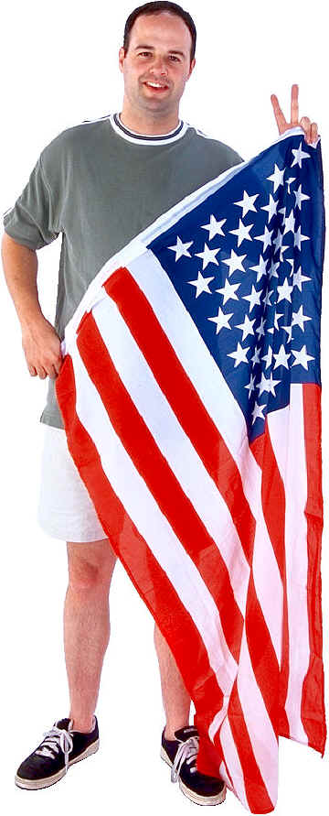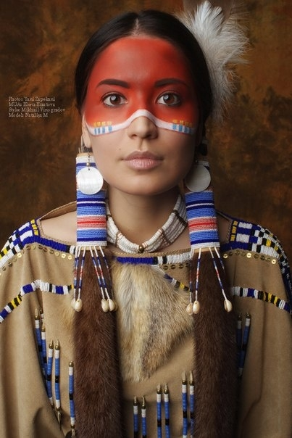

The country was first inhabited by Native Americans who lived in tribes: Sioux, Apache, Pueblo, Cherokee, Navaho, Iroquois, etc. The Native American population had been exterminated for centuries by the European settlers. Today it has risen from its low point of 235,000 in 1900 to 2.5 million at the turn of the 21st century.
There are 310 reservations in the U.S.A. inhabited by about one third of Native Americans. The remaining two thirds live in cities. The problems they face are poverty, unemployment and alcoholism. These problems are caused by the incapability of Native Americans to adapt to modern American values. Presently, the majority of Native Americans live in such states as California, Oklahoma, Arizona and New Mexico.

Answer the questions:
1) How many people live in the United States of America?
2) What part of the country is more populated?
3) List the main reasons for the racial and ethnic diversity.
4) List the names of Native American tribes
5) How many reservations are inhabited by Native Americans?
6) The main problems faced by Americans?
7) What are the most populated states by Native Americans?

In the 2000 Census and subsequent United States Census Bureau surveys, Americans self-described as belonging to these racial groups:
* White: those having origins in any of the original peoples of Europe, the Middle East, or North Africa.
* Black or African American: those having origins in any of the Black racial groups of Africa.
* American Indian or Alaska Native, also called Native Americans: those having origins in any of the original peoples of North, Central and South America, and who maintain tribal affiliation or community attachment.
* Asian, also called Asian American: those having origins in any of the original peoples of the Far East, Southeast Asia, and the Indian subcontinent; frequently specified as Chinese American, Korean American, Indian American, Filipino American, Vietnamese American, Japanese American, etc.
* Native Hawaiian or Other Pacific Islander: those having origins in any of the original peoples of Hawaii, Guam, Samoa, or other Pacific Islands; see also Pacific Islander American.
* Some other race: respondents write in the race they consider themselves to be, if different from the foregoing categories. This category captures responses such as Mestizo, Creole, and Mulatto, but among the write-in entries reported in the 2000 census were also South African, Moroccan, Belizean, Mexican, Puerto Rican, Cuban and Wesort, mixed, interracial, and others. This is not a standard OMB race category.
* Two or more races, widely known as Multiracial: those who check off and/or write in more than one race. There is no actual option labelled "Two or more races" or "Multiracial" on census and other forms; only the foregoing six races appear, and people who report more than one of them are categorized as people of "Two or more races" in subsequent processing. Any number, up to all six, of the racial categories can be reported by any respondent.

Choose the correct variant:
1. The U.S. has often been called "a nation of immigrants". Many different cultural traditions, ethnic sympathies, national origins, racial groups, and religious affiliations make-up "we the people".
The first people on the American continent came from .... They came to Alaska at various times when the sea level dropped. The first migration might have been as early as 40,000 years ago.
a) Africa; b) Asia; c) Europe; d) Australia.
2. The story of the westward growth of the United States was also the story of the destruction of the Native Americans, or ....
a) Indians; b) Polynesians; c) Africans; d) Australians.
3. ... states–especially California, Oklahoma, Arizona, and New Mexico–have the largest Indian population.
a) Northern; b) Western; c) Southern; d) Eastern.
4.Beginning in the 1600s, the British settled ... part of North America.
a) the eastern; b) the western; c) the northern; d) the southern.
5. By the time of the American Revolution (1776), the culture of American colonists had been thoroughly ... .
a) British; b) French; c) Indian; d) Dutch.
6. From 1620 to 1820 by far the largest group of people to come to the United States came against their will. Those people were ....
a) Polynesians; b) West Africans; c) Afghans; d) Australians.
7. Beginning in the 1820s, the number of immigrants coming to the United States began to increase rapidly. Faced with problems in ...–poverty, war, discrimination–immigrants hoped for, and often found, better opportunities in the United States.
a) Europe; b) Russia; c) Africa; d) Australia.
8. Although immigration from northwestern Europe continued, from the 1870s to the 1930s even more people came from the countries of southern and eastern Europe. In the 1920s discrimination and prejudice in the U.S. led to laws ... immigration. Immigration ... until 1960s, when these laws were changed.
a) permitting; accelerated; b) forbidding; stopped;
c) limiting; slowed down; d) accelerating; increased.
9. In the nineteenth century, laws limited ... immigration. Also ... in the U.S who had come to California, met with widespread discrimination.
a) Iranian; Iranians; b) Indian; Indians; c) Korean; Koreans; d) Asian; Asians.
10. Since the mid-1960s, with changes in immigration laws ... have been a major immigrant group. In the 1980s, for example, almost half of all immigrants were ... .
a) Philippians; Philippine; b) Cambodians; Cambodian; c) Asians; Asian;
d) Thailandians; Thailandian.
11. ... are one of the fastest growing groups in the U.S. population. Within 25 years, they will be the largest minority.
a) Puerto Ricans; b) Hispanics; c) Indonesians; d) Iranians.

Lecture 4
The system of the government in the UK

Goal:To provide students with some information about the system of the government in the UK
Students will be able:
1 to learn the most important documents of the UK(Magna Carta, Habeas Corpus Act, The Bill of Rights, Petition of Right, Statute of Westminster Reform Act of 1832)
2 to acquire some knowledge about the parliamentary monarchy
The UK is a parliamentary monarchy based on the unwritten constitution. The most important documents are:
- Magna Carta
- Habeas Corpus Act
- The Bill of Rights
- Petition of Right
- Statute of Westminster
- Reform Act of 1832
Legislative power

The House of Commons
The House of Lords
The Queen

Executive Power

The Cabinet of Ministers
The Prime-Minister

Judicial Power

The Supreme Court
The system of courts

Questions:
1.What are the most important constitutional documents of the UK?
2.Who is Lord Chancellor?
3.What does the Supreme court consist of?
4.How many members are there in the Cabinet?

- Fill in the blanks with the correct words.
- One of the principles of the unwritten constitution is the …of Parliament.
- The formal Head of the UK is ____.
- The Queen meets the Prime Minister every week and receives copies of _____.
- The House of Lords has more than _____ members.
- One of the oldest functions of the House of Lords is _____.
- The Chairman of the House of Lords is ______.
- The House of Commons plays the major part in _____.
- Each MP represents one _____.
- The leader of the party with most seats in the House of Commons becomes _____.
- Voting takes place on _____.
- The members of the Cabinet meet about once a week in _____.
- The Conservatives’ nickname is _____.
- The Tories were opposed by _______.
- Around 1900 ______ Party was formed as the political arm of ______.

- Are the statements true or false? Correct the false statements.
- The Parliament consists of the House of Lords and the House of Commons.
- The parliamentary electoral system of Great Britain encourages the domination of one major political party.
- The two big parties – the Conservative Party and the Labour Party.
- There are 659 Lords in the House of Commons.
- MPs are elected only at a general election.
- The Government is formed by the second largest political party and its leader becomes the Prime Minister.
- The elections must be held at least every five years.
- The Labour Party was formed as the political arm of business directors.

Quiz :
Question 1: | What is the actual name of London's Houses of Parliament?  (a) The Palace of Westminster (b) The Chambers of Westminster  (c) The Courts of Westminster
Question 2: | In which year were the Houses of Parliament that stand today completed?  (a) 1670 (b) 1770 (c) 1870
Question 3: | Who is the United Kingdom's Head of State?  (a) The Queen (b) The Prime Minister (c) The Archbishop of Canterbury
Question 4: | The British Parliament is made up of the 'House of Lords' and the 'House of Commons'. Which one of the following statements is true?  (a) Only the members of the House of Lords are elected by the public.  (b) Only the members of the House of Commons are elected by the public.  (c) All the members of both Houses are elected by the public.
Question 5: | What is the formal title of the Minister who is responsible for the British Government's financial and economic matters?  (a) Chancellor of the Bank of England  (b) Chancellor of the Budget  (c) Chancellor of the Exchequer
Question 6: | Every year, the Chancellor (mentioned in Question 5) famously takes his budget plans to parliament in a ..... ?  (a) wooden chest (b) red leather case (c) armoured convoy
Question 7: | 'Whips' are the names of particular officials in a political party. One purpose of whips is to ensure that ....?  (a) elections are carried out fairly  (b) MPs support their party on important votes  (c) the Houses of Parliament are safe from intruders
Question 8: | According to UK law, a general election must be held every .... ?  (a) 3 years (b) 4 years (c) 5 years
Question 9: | A 'green paper' is the name of a government document which is usually the first step in creating or changing government policy. What is issued in response to a green paper?  (a) A white paper (b) A red paper (c) A yellow paper
Question10: | What is the name of the senior officer in the House of Lords who is responsible for maintaining order in the House and controlling access?  (a) Black Rod (b) Silver Rod (c) Gold Rod

Lecture 5
Economy of the UK

Goal:to get acquainted with the economy of the UK, its economical regions
Students will be able:
1 to get some additional information aboutcharacteristic features of the British industry
2 to learn about 6 main economic regions

Great Britain is highly-developed industrial country with intensive development of agriculture. Industry gives about 20% of export. 2% of wealthy population keeps 50% of the national wealth. Britain is the 2d country after Japan as a country-creditor. The characteristic features of the British industry are: intensive growth of modern branches which use modern technologies. It’s the ideal country for cattle-farming. This is the land of pastures. They take the 3d part of the whole territory. All British outward transportations are connected with navy and air transport. Great ports are: London, Southampton, Liverpool. The biggest airports are: Heathrow and Gatwick. Tunnel in the English Channel is the representative of the railway.
In Britain we can speak about 6 main economic regions:

- Southern England
- Central economic region
- Northern England
- Scotland
- Wales
- Northern Ireland

Questions:
1What are the characteristic features of British economy?
2What are main economic regions?
3What are the great ports?
4What are the biggest airports?

Read these words paying attention to the stress:
eco'nomics e'conomist eco'nomically
e'conomy eco'nomic to e'conomize
e'conomies eco'nomical e'conomizer
Note: Ударение обычно ставится перед ударным слогом.
Choose the correct word:
1) I am a student of (economy, economics) now. 2) At school I didn't study the (economy, economics) of Great Britain. 3) I hope he'll make a good (economist, economy). 4) There are many (economic, economical) to spend money and time (economical, economically). 6) This car (economize, economizes) fuel.

Read the text and answer the questions:
Speaking about the economy of Great Britain it should be mentioned that as in many other countries the economy of Britain is based mostly on private enterprises. Different services and manufacturing are well developed, while the agriculture does not take the leading place here. Britain has the possibility to use oil and natural gas from the North Sea and this makes the country self-sufficient in energy. More than half of domestic oil production Britain exports to other countries.
We know that for any economy the international trade is very important. In Britain nearly 25 % of national production of goods and services are exported. 1981-1989 were the years of economical growth in Britain. But unfortunately as it often happens after the growing comes the recession. In this case Great Britain was not an exception. Only in 1992 the rate of inflation went down. Today we can say for sure that manufacturing production of Britain grows much faster than in any other industrial country.
To keep the economy at high level the government controls the inflation and public spending and borrowing. Markets and promote enterprises are note left without attention. Privatisation also takes its place. Nearly all major businesses are privatized now.
Another question worth mentioning is taxes. In Britain this problem is solved by reducing personal and corporate income taxes. Any of the Industrial relations are legal. Small businesses are supported by the government. As we know Great Britain is a member of European Community, so it is a good place for investments.

QUESTIONS
1. What is the economy of Great Britain mostly based he?
2. What manufacturing is less developed in Britain?
3. What makes the country self-sufficient in energy?
4. What were the years of economical growth in Britain?
5. What does the government do to keep the economy it high level?
6. Why is Great Britain a good place for investments?

The economy of the United Kingdom
The economy of the United Kingdom is the fifth largest in the world in terms of market exchange rates and the sixth largest by purchasing power parity (PPP). It is the second largest economy in Europe after Germany's. Its GDP PPP per capita in 2007 is the 22nd highest in the world.
The United Kingdom is one of the world's most globalised countries. The capital, London, is the major financial centre of the world, in front of New York City, Hong Kong and Singapore according to a report compiled by the City of London.
The British economy is made up (in descending order of size) of the economies of England, Scotland, Wales and Northern Ireland. The UK became a member state of the European Community, in 1973, and ratified the Maastricht Treaty making it a European Union state, at the inception of the EU in 1993.
In the 1980s, under the Government of Margaret Thatcher, most state-owned enterprises in the industrial and service sectors, which since the 1940s had been nationalized, were privatized. The British Government now owns very few industries or businesses - Royal Mail is one example.
The United Kingdom, according to the International Monetary Fund, in 2007 had the ninth highest level of GDP per capita in the European Union in terms of purchasing power parity, after Luxembourg, Ireland, the Netherlands, Austria, Denmark, Sweden, Belgium and Finland. However, in common with the economies of other English-speaking countries, it has higher levels of income inequality than many European countries.
During August 2008 the IMF has warned that the UK economic outlook has worsened due to a twin shock: financial turmoil as well as rising commodity prices. Both developments harm the UK more than most developed countries, as the UK obtains revenue from exporting financial services while recording deficits in finished goods and commodities, including food.
The UK has the world's third largest current account deficit, despite significant oil revenues. This is mainly the result of a large deficit in the trade in manufacture goods. During May 2008, the IMF advised the UK government to broaden the scope of fiscal policy to promote external balance.
Although the UK's "labour productivity per person employed" has been progressing well over the last two decades and has overtaken productivity in the united Germany, it lags around 20% behind France's level, where workers have a 35-hour working week. The UK's "labour productivity per hour worked" is currently on a par with the average for the "old" EU (15 countries).
The United Kingdom currently ranks 16th on the Human Development Index.

Vocabulary
Globalised | объединенный
Report | сообщение
Descending | спуск
MaastrichtTreaty | Соглашение Маастрихта
State-owned | Принадлежащий государству
Chronicweakgrowth | Хронически слабый рост
Fewindustries | Некоторые отрасли промышленности
SustainedUnemployment | Длительный Безработица
Remainrelativelylow | Остались относительно низкими
Monetary | Денежно-кредитный
Inequality | неравенство
Outlook | перспектива
Worsened | ухудшенный
Rising | повышение
Harm | вред
Average | Среднее число
privatised | приватизированный

Questions:
1. What is GDP PPP of the United Kingdom per capita?
2. When did the UK become a member state of the European Community? When did it ratify the Maastricht Treaty?
3. Are there many state-owned enterprises in the industrial and service sectors of Great Britain?
4. What is the level of GDP of the UK per capita according to the International Monetary Fund?
5. Why did the UK economic outlook worsen in August 2008?
6. Why does the UK have the world's third largest current account deficit?
7. What is the UK's "labour productivity per person employed"
8. What is the current UK's "labour productivity per hour worked"?

Lecture 6
British system of education

Goal:to get acquainted with the system of education of the UK
Students will be able:
1 to learn more about stages of education in the UK
2 to differentiate three types of universities
3 to learn about the National Curriculum

The system of education in GB is determined by the National Education Acts. In 1870 the universal education was adopted in GB. There are state and private schools. The oldest private school is Eton. The National Education Act of 1944 provided 3 stages of education: primary, secondary and further education.
The National Curriculum which was introduced in 1988 sets out in detail the subjects that children should study and the level of achievement they should reach by the ages of 7, 11, 14 and 16 when they are tested.
English universities differ in date of foundation, size, history, tradition, general organization, methods of instruction and way of students’ life. The 2 intellectual eyes of Britain are: Oxford and Cambridge ( the 1st type). The 2d type is: the Scottish universities of St. Andrew, Glasgow, Aberdeen and Edinburgh date from the 15-16th centuries. The 3d type is so called Redbrick universities.
In 17-18th centuries there was a high point of the development in mechanics, physics, chemistry, physiology and optics. The most scientific organizations are: London Royal Society, British Academy, Royal Academy of Science.

Questions:
1What are the stages of education?
2What types of British schools do you know?
3When was the National Curriculum introduced?
4What degrees do British students get after graduating from the university?

Quiz:
- In Britain you have to attend school between:
- 5 and 16
- 5 and 18
- 7 and 16
- A comprehensive school is…
- a school of languages
- a school for 5-11 year olds
- a school for 11-16 years olds
- “Public” schools like Eton are very expensive-it costs more than $15000 a year to be educated at Eton, for example. What proportion of British children attend “public” schools?
- 7%
- 10%
- 15%
- In 1989 a new National Curriculum was introduced into British schools. Ten subjects had to be studied. Three of these subjects called “core subjects” were chosen for special attention. Here are the ten subjects to be studied. Which do you think are the “core subjects”?
- English
- History
- Geography
- Art Physical
- Science
- Mathematics
- A Foreign Language
- Design and Technology
- Education music
- The average pupil-teacher ratio in British schools is…
- 19
- 22
- 25
- 30
- How old are British children when they start their education?
- 5 years old
- 6 years old
- 7 years old
- Is education in Britain free?
- Yes
- No
- Yes but only at State Schools, Private Schools are payable
- What is homeschooling?
- Students don’t go to school, they learn through Internet
- Students don’t go to school at all
- Students don’t go to school but their parents teach them at home
- What colors are school uniforms in Britain?
- White and black
- White and black or grey, the color of jumper is the choice of the schools
- Free-form
- What are the compulsory subjects at British school?
- Dance
- Football
- Science
- What are the after-school activities?
- Drama
- Geography
- Maths
- Which of the below would a typical student in Britain go to from the ages of 5-11?
- Nursery school
- Secondary school
- High school
- Primary school
13. SAT is
- The preliminary exam which students take to get into university
- The exam which students take before leaving secondary school
- The exam which children take in primary school

Lecture 7
Arts and mass media in the UK

Goal: to get acquainted with the history of arts in the UK
Students will be able:
1 to get some additional information about arts in the UK
2 to learn about famous artists, architects and musicians
3 to speak about famous paintings

The art of designing and erecting buildings was the main in the 11-14 centuries. The majority of thecathedrals and monasteries were built late in the 11th and early in the 12th century. Romanesque style is a transitional style of European architecture prevalent from the 9th to the 12th century. Later in the 13th century Gothic architecture was introduced. Inigo Jones was the 1st architect who in the 17-18th centuries brought the Italian Renaissance style to the British Isles. Christopher Wren was a talented architect who used the classic forms with great purity and correctness. Thomas Chippendale was a celebrated cabinet-maker, who produced beautiful, elegant furniture. The style of architecture characteristic of the reigns of 4 Georges who ruled Great Britain from 1714 to 1830 is called Georgian. The style which became popular in the 19th century is called Victorian. The most known architect of that time was Charles Barry.
The 15th century was the period when folk music flourished. Choral singing and polyphony influenced the creative activity of John Dunstable who was a conspicuous composer of the 15th century. The most famous composer of the 17th century Henry Purcell composed the 1st opera “Dido and Aeneas”. One of the prominent composers of today is Elton John.
The theatre appeared in England in the 14-15th centuries. In 1576 the 1st theatre was built in London. The Globe was opened to the public in 1599 and it started the golden age of the theatre in England. Great playwrights of that period were Shakespeare, University Wits. The great actor who contributed much to realistic acting was David Garrik. Nowadays dramatic training is provided by the Royal Academy of Dramatic Art, the Central School of Speech and Drama.
It is usual to regard English painting as beginning with the Tudor period. The 1st truly English painter was William Hogarth. His masterpiece is called “Marriage-a-la-Mode”. Joshua Reynolds was a conspicuous painter, the leader of the English school of portrait painting of the 18th century and the 1st president of the Royal Academy of Arts. Other prominent painters of GB are: Thomas Gainsborough, George Romney, JosephMallord William Turner.

Questions:
1When was Romanesque style introduced?
2Who was Christopher Wren?
3In what century did folk music flourish?
4When did the theatre appear in England?

Read the text and do the tasks:
Painting in England in the period of the 15th-17th centuries was represented mostly by foreign artists.
In the 16th century Hans Holbein the Younger (1), a well-known painter was invited to London by the King Henry VIII. Though he did not create any painting school in England he nevertheless played an important part (2) in the development of English portrait art. Later Charles I made the Flemish painter Van Dyck (a pupil of Rubens (3)) his Court painter. Van Dyck founded a school of aristocratic portrait painting. Another painter Peter Lely came from Holland in 1641. He became celebrated for his portraits of the idle and frivolous higher classes.
The 18th century was the century during which a truly national painting school was created in England. Portrait art at that time was the main kind of painting. It depended upon the conditions under which the English painting school developed.
The Industrial Revolution in England greatly influenced art as a whole, and painting in particular (4). Such trends in painting (5) as the genre school, realistic landscape and portraiture schools (6) expressed the social contradictions of English life. The new trends may be traced in the works of Wilkie, Lawrence and Constable.
Sir David Wilkie (1785-1841), the leader of the genre school, preferred pictures from which a moral concerning the simple virtues (7) could be drawn. One of his well-known pictures is Village Politicians. With this trend not only portraits of common people but their life and labour were introduced in art.
The second tradition, that of realistic landscape, was represented by John Constable (1776-1837). In portraiture Sir Thomas Lawrence (1769-1830) continuing the manner of the 18th century introduced more realism.
In the second part of the nineteenth century England entered upon important stages of her artistic development. Some known painters – Dante Gabriel Rossetti and others formed themselves into a ‘brotherhood’ with the title of Pre-Raphaelites (8) that expressed their deep admiration for the masters who preceded Raphael. This school had a great influence on the development of English pictorial art.
Portrait art always occupied an important part in English painting and nowadays there are prominent portraitists who continue the traditions of the famous English masters. These traditions are obvious in the portraits of by Graham Sutherland (1903), Ruskin Spear (1911), Paul Hogarth (1917).
With the 20th century impressionism, cubism, abstractionism entered English painting and certainly influenced it, though many gifted artists have found and are following their own realistic way in art. Most of the famous British painting collections may be seen in museums and art galleries of London: the Tate Gallery (9), the National Gallery (10) and the National Portrait Gallery and others.

Vocabulary
1. Hans Holbein the Younger –ГансГольбейнМладший (1497-1543), немецкийхудожник
2. to play an important part –игратьважнуюроль
3. Rubens - Рубенс (1577-1640), знаменитыйфламандскийхудожник
4.in particular - особенно
5.trend in painting –течениевискусстве
6. realistic and landscape portraiture schools –школыреалистическогопейзажаипортрета
7. virtue ['vɜːʧuː] –положительнаячерта, добродетель
8. Pre-Raphaelites–английскиехудожники, которыетребоваливозвращенияискусстваэпохираннегоРенессанса
9. theTateGallery - галереяТейт, постояннаялондонскаявыставкапроизведенийискусстваискульптуры
10. TheNationalGallery–НациональнаягалереявЛондоне
Questions
1.What foreign artists represented painting in England in the 15th-17th centuries?
2. When was a truly national English painting school created?
3. What trends in painting expressed the social contradictions of English life?
4. Who was the leader of the genre school in England?
5. What did the painters of the second part of the 19th century of England express in their works?

Mass Media in the UK
- Answer the questions
- What popular British newspapers do you know?
- What quality British newspapers can you remember?
- What types of media are used for broadcasting news?
- What is the home of British press?
- Which 2 groups are British papers divided in?
- What other types of papers were mentioned?
- Match the words with the right description!

1 brochure | a) a newspaper with small pages, short articles and lots of photos;
2 rag | b) a newspaper that is printed on large sheets of paper; is considered to be more serious than other papers;
3 tabloid | c) a magazine or booklet with pictures that gives information about a product or service;
4 broadsheet | d) people refer to a newspaper as a rag when they have low opinion of it;
5 review | e) one of the parts into which a newspaper is divided
6 frontpage | f) the title of a newspaper story, printed in large letters at the top of it;
7 section | g) a report in a newspaper or magazine in which someone gives their opinion of a new book, film, concert ect.
8 headline | h) a front page article or picture appears on the front page because it’s very important or interesting;
9 article | i) a correspondent who sends news reports from a foreign country;
10 feature | j) the person who is in charge of a newspaper and who decides what will be published in it;
11 supplement | k) a journalist who is in charge of a particular section of a newspaper;
12 reporter | l) some sensational information catching everybody’s attention;
13 editor | m) someone who writes new articles or reports;
14 journalist | n) a prominent or special article or section in a periodical;
15 columnist | o) a piece of writing in a newspaper or magazine;

Lecture 8
Geographic outline of the USA
Goals:
to give students basic information about the subject they are going to learn about;
to inform students about the geographical position of the USA;
to enrich the students outlook on the USA
Students will be able:
1 to get better understanding of the notions:theUSA,the District of Columbia
2 to be ready to talk about peculiarities of climate,relief
3 to be able to discuss characteristics of mineral resources

The United States of America has an area of 9,4mln square kilometers almost all of which is on the American continent. There are 50 states and one Federal District, created as a site for the Federal Capital, Washington, and known as the District of Columbia.
The USA is considered to be the 4th largest country in the world. The 48 conterminous states extend from latitude 25' N to 50' N and longitude 125' W to 67' W. The other two states, Alaska and Hawaii are situated near the Arctic circle and in the tropical part of the Pacific Ocean.
Mount McKinley in Alaska of 6,194 meters above the sea level is the highest point in the USA, while part of Death Valley in California is 89 meters below sea level.
The Central Part

Central Plains
Great Plains
The Rocky Mountains

Mountains of the USA

The Rocky Mountains
The Cordillera parallel

The Appalachian Mountains

The Ozark Plateau
Every type of climate can be found in the USA, from arctic in Alaska to subtropical in Florida. The extreme variations of the temperatures are: In Dakota they have reached a maximum of 49’ and a minimum of –60’.
The main rivers of the country are: the Mississippi, the Missouri, the Ohio, the Tennessee, the Colorado, the Columbia, the Rio Grande, the Yukon, the Chicago. There are 5 great lakes on the territory of the USA: Superior, Michigan, Huron, Ontario and Erie. There is the Great Salt lake in the state Utah.
The forests of the USA are presented by coniferous and deciduous wood. They abounded in animals of all kinds such as: deer, raccoons, gray and red squirrels, rabbits, hares and wolves.
The USA include 6 regions:

Today 3,472 square miles of the magnificent wild country are preserved for millions of visitors to enjoy. 45 areas are set side as national parks.

Questions:
1 What is the USA washed by?
2What is the area of the USA?
3What is the highest mountain of the USA?
4What are main regions of the USA?

Read the text:
Geographical position of the USA
The USA is the 4th largest country in the world (after Russia, Canada and China). It is situated in central North America and stretches fromthe Pacific to the Atlantic Ocean. It borders on Canada in the north and Mexico in the south and has a sea-border with Russia. It also includes Alaska and Hawaii.
The total area of the country is 9.4 million square kilometers. The enormous size of the country influences the diversity of landscape, climate and even people.
The West is a mountainous area of the Rocky Mountains, the Cordillera and the Sierra Nevada. The highest peak is Mount McKinley inAlaska (6,000 meters).
As compared with the Appalachians in the east, the Rocky Mountains are sharp and rugged, over 4,000 meters high, rich in gold, copper, lead, silver and other minerals.
The longest rivers are the Mississippi (6,400 kilometers), «the father of waters», the Missouri (1,600 kilometers), the Colorado wild, restless and angry, the Columbia full of quiet dignity and the Rio Grande (3,200 kilometers), a national boundary between the USA and Mexican sizes. The largest state is Alaska.
The Colorado forms the Grand Canyon, which strikes one's imagination as a fabulous phenomenon of nature. Its perpendicular walls go up to 1,500 meters above the river level. The USA has thousands of lakes of all kinds
The Great Lakesmake up the largest group; they are the greatest collection of fresh water lakes in the world with the total area equal to that of Great Britain. They are Lakes Huron, Erie, Ontario, Michigan, Superior. Here the famousNiagara Falls precipitate from the height of 50 meters. Among salty lakes the Great Salt Lake in Utah and the Salton SeainCaliforniaare the most famous. They are rich in salt (6,000 million tons).

“True” or “False”.
1.The USA is the 10th largest country in the world.
2.It borders on Kazakhstan in the north and Mexico in the south and has a sea-border with Russia.
3.The longest rivers are the Mississippi (6,400 kilometers), the Missouri(1,600 kilometers)
4.The USA is situated in the central northern part of America.
5.The total area of the country is 10 million square kilometers.
6.The famous Niagara Falls precipitate from the height of 50 meters.
7.The USA has hundreds of lakes of all kinds.
Show on the map:
1Oceans ,the USA is washed by
2The longest river in the USA
3The highest mountain peak in the USA
4 Five Great Lakes
5America’s largest state
6The most famous waterfall in the USA

Lecture 9

Main historic events of the USA
Goal:
to give some additional information about main historic events, its earliest inhabitants and the main historic events
Students will be able:
1 to get better understanding of the most important historical documents like Emancipation Proclamation, to learn about nativeAmericans: who they were, their economical position nowadays
2 to appreciate A.Lincoln's contribution to abolishing slavery in the USA
3 to realise the importance of American Revolution and War for independence

The earliest inhabitants of America may have arrived over 25,000 years before Columbus. North America’s first settlers were the ancestors of the Indians. They came from Asia, across the Bering Strait. Indians lived in a kind of buffalos, they grew a lot of crops. The most important Indian food plants were tobacco and corn.
The first black colonists –20 africans were brought to Jamestown in 1619 by a Dutch ship. They were indentured.
The two battles at Lexington and at Concord became known as American Revolution and the beginning of the War for Independence. The battle of Yorktown marked the end of the fighting, but it was two years before the peace treaty was signed where GB agreed that 13 colonies would be independent, the new nation was called the United States .
The political divisions over slavery in the Whig and Democratic parties led to the formation of the Republican party whose main principle was opposition to the extension of slavery. When A. Lincoln (republican candidate ) was elected President in 1860 South Carolina announced about the desolation.
From the Union and together with other states formed the Confederacy with a constitution based on slavery. Lincoln hoped that the South would rejoin the Union but in April 1861 the Civil War started. On January 1, 1863 A. Lincoln signed the Emancipation Proclamation. On April, 1865 Lee and his army surrendered in Virginia and it was the end of the war.

Questions:
1 When and where were the first black colonists brought to America?
2 Who were Native Americans?
3 What president abolished slavery in America?What document was signed?
4 When did the War of Independence start? Who drafted Declaration of Independence and when?
5 Who were “The Founding Fathers”of American Revolution?

Choose the correct variant:
1.How many states are there in the USA?
А. 48; B. 52; C. 50.
2.Who was the first president of the USA?
A. George Washington;
B. Abraham Lincoln;
C. Ulysses Grant.
3. What is the largest city in the USA?
A. Washington; B. New York; C. Chicago.
4. What colour was originally the President’s House?
A. grey; B. white; C. light blue.
5. What is the tallest skyscraper in New York?
A. the United Nations Organization building;
B. the World Trade Centre;
C. the Empire State Building_
6. The flag of the USA has
A. 3 red and blue and white stripes;
B. 13 red and white stripes;
С. 13 red stripes.
7. 50 stars represent its
А. 50 cities and towns;
В. 50 states of the country;
С. 50 American presidents.
8. What is the USA especially rich in?
А. iron; В. coal; С. gold.
9. What is celebrated on July,4?
А. President s Day;
В. Independense Day;
С. Thanksgiving Day.
10. Where is Hollywood?
А. San Francisco; В. New York; С. Los Angeles.
11. What is the biggest centre of the automobile industry?
А. New York; В. Detroit; С. Los Angeles.
12. Who is the head of the state and the government?
А. a king; В. a queen; С. a president.
13. What kind of state is the USA?
А. a kingdom; В. a federal republic; С. a democratic republic.
14. What is the national symbol of America?
А. The rose; В. The bald eagle; С. The shamrock.
15. Who was the first man on the moon?
А. Yuri Gagarin;
В. John Glenn;
С. Neil Armstrong

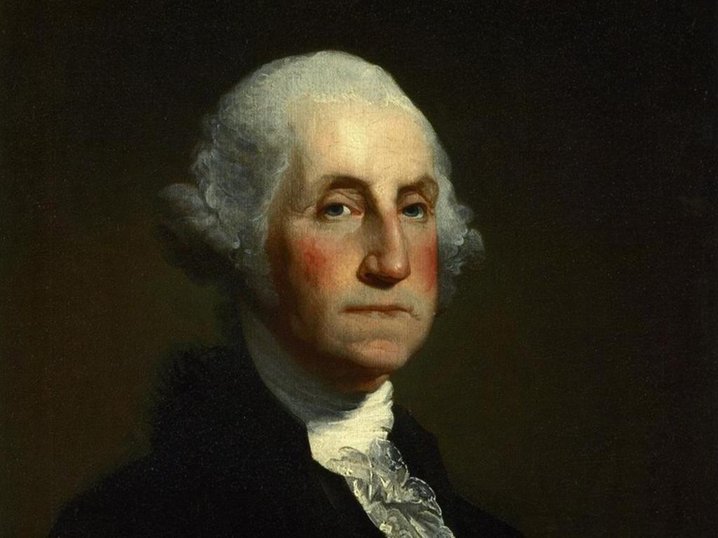
- Who are these people?
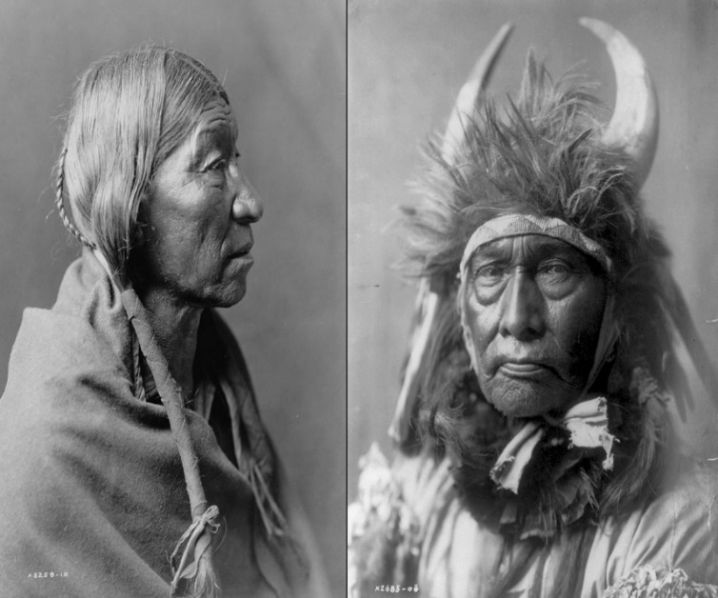

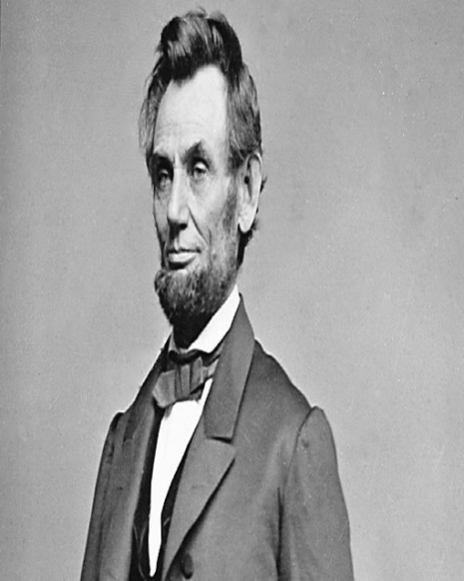
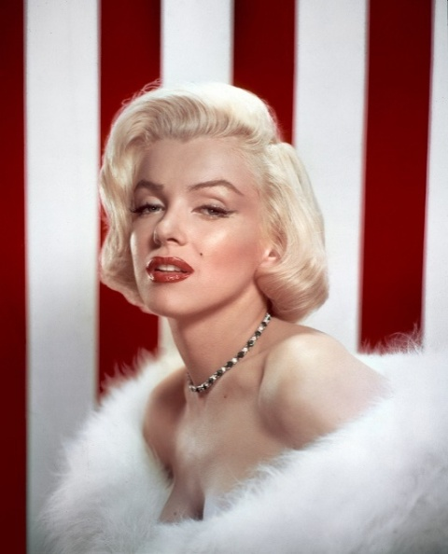
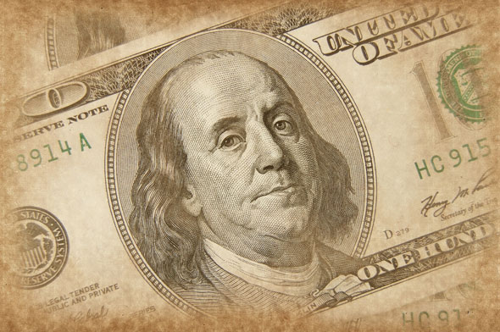

III. What's on the photos? Use hints..
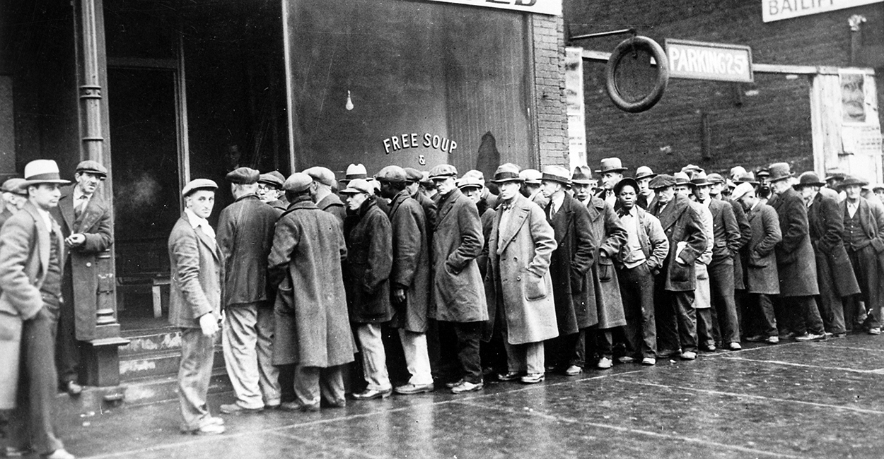
А.

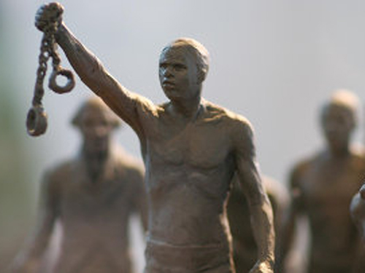

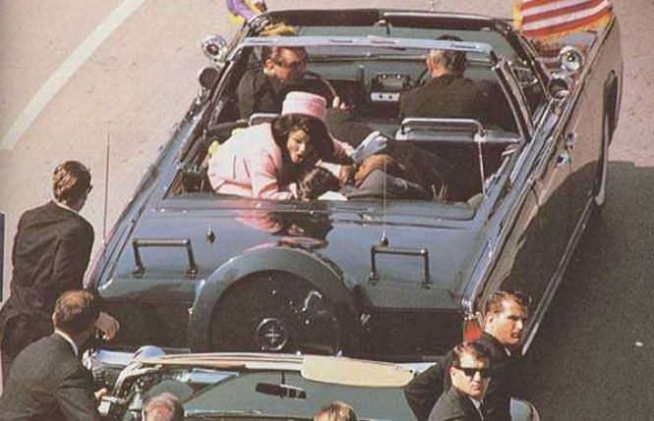

Lecture 10

The population of the USA
Goal: to learn some facts about population of the USA
Students will be able:
1 to get some facts about the most densely and sparsely populated areas of the USA
2 to realise why America is called "melting pot" “a nation of immigrants”

The United States of America is the fourth country in the world in terms of population. The population of the USA is about 280 mln people. The average age is 33. America’s population remains richly diverse. 87,5% are classified as white by the US Bureau of Census. The most rapidly growing group is the Hispanics. The most populous area is the relatively small Northeast, which accounts for nearly one fourth of the nation’s population.
The US has often been called “a nation of immigrants”. The first people on the American continent came from Asia. From 1620 to 1820 the largest group of people came to the USA against their will ( west Africans-slaves ). In the 1920s discrimination and prejudice in the USA led to laws limiting immigration.
The average density of population in the USA is about 26 persons per square klm. The State of New Jersey is the most densely populated ( 374 persons per square klm ). By contrast Alaska has only 0,3 persons per square klm.

Questions:
1 What state is the most densely populated?
2 What state is the least populated?
3 What percentage of population is classified as “white”?
4 Why is the USA called a”melting pot”?
5 What immigration group is the largest in the USA nowadays?

Read the text and answer the questions:
Population of the USA
The United States has long been known as a “melting pot,” because many of its people are descended from settlers who came from all over the world to make their homes in the new land, which was sparsely populated by native Indian tribes. The first immigrants in American history came from England and the Netherlands. Attracted by reports of great economic opportunities and religious and political freedom, immigrants from many other countries flocked to the United States in increasing numbers, the flow reaching a peak in the years 1880— 1914.
Some 1,534,000 Indians,. Eskimos and Aleuts, descendants of North America’s first inhabitants, now reside in the United States. Most live in the west, but many are in the south and the north central area. Of more than 300 separate tribes, the largest is the Navaho in the south-west.
Black people were first brought to America from Africa as slaves. Blacks currently make up more than 11 percent of the population. They once lived mainly in the agricultural South but now are scattered throughout the nation. In the Midwest city of Chicago, for example, there are 1.2 million black residents — more than three times as many as in 1940. New York State has the largest black population — 2,402,000, an increase of close to one million in 20 years.California, on the Pacific Coast, now has the nation’s largest population, and the Atlantic Coast state of New York is second. Another western state, Colorado, is growing almost twice as fast as the nation as a whole. Some other western states have had spectacular population booms: Arizona has more than doubled its population since 1960, while Nevada has almost tripled its population in the same period. The southern state of Florida, known for its pleasant climate, has almost twice the number of residents it had in 1960.

Questions:
1. How was The United States called ? Why?
2. Where did the first immigrants come from?
3. What tribe was the largest in North America?
4. Who lived in the agricultural South?
5. How many people are living in the USA?
6. Which state has the nation’s largest population?
7. Which state has almost twice the number of residents?

Lecture 11

The system of government of the USA

Goal:to learn about the system of government of the USA
Students will be able:
1 to define the pecularities of American constitution
2 to give the definitions of"amendment","Legislature", "Judiciary”

The American Constitution is based on the doctrine of the separation of powers between the executive, legislative and judiciary. The constitution of the USA was adopted after the War for Independence on September 17, 1787. It consists of the Preamble and 7 articles. 27 amendments were added to the original text. The first 10 amendments are known as the Bill of Rights. Americans feel that all freedoms proclaimed in the constitution there is only one freedom-freedom of enterprise.
Legislative power in the American government lies with Congress, which consists of 2 chambers or houses – the Senate and the House of Representatives. Each state has it’ own government, following the Washington pattern-State Assemblies or Legislatures with 2 chambers. The main task of Congress is to make laws.
The Presidency of the USA is the highest governmental office. President of the USA is the head of the State and the Government, he is also the Commander-in-Chief of the US Armed Forces. President is assisted by Vice-President and the Cabinet.
In the USA the judiciary can be federal and state. Each is independent of the other with the exception that the US Supreme Court may under special circumstances review a state court decision. The US Supreme Court is the highest tribunal in the USA, it includes a Chief Justice and 8 Associate Justices.
The President of the USA is elected on the 1st Tuesday after the 1st Monday in November of a leap year and takes his office at noon on January. The President is not elected directly but by an Electoral College.
Today the US has two major parties: Democratic and Republican.

Questions:
1 When was the constitution adopted? What does it consist of?
2 What is “amendment’?
3 How many amendments are there in American Constitution?
4 What do they call “The Bill of Rights”?
5 What does the Congress consist of?
6 What does the Supreme court consist of?
7 Who can be the president of the USA? When is he elected?

Read the text and do the tasks:
The United States is a federal union of 50 states, with the District of Columbia as the seat of the national government. The Constitution outlines the structure of the national government and specifies its powers and activities. Other governmental activities are the responsibility of the individual states, which have their own constitutions and laws. Within each state are counties, townships, cities and villages, each of which has its own elective government.The President names the heads of federal departments while judges are either elected directly by the people or appointed by elected officials. The Constitution divides the powers of the government into three branches – the executive, headed by the President; the legislative, which includes both houses of Congress (the Senate and the House of Representatives); and the judicial, which is headed by the Supreme Court. The Constitution limits the role of each branch to prevent any one branch from gaming undue power. The Supreme Court is the highest court in the United States. There are 9 justices in Supreme Court.The whole system of American government is based on the principles established in the Constitution and Bill of Rights.The state governments follow much the same pattern as the federal government. Each has a governor as the chief executive, with power divided among the executive, legislative and judicial branches. State governments manage such affairs as maintaining order, educating children and young adults and building highways. The federal government deals with national problems and international relations and with regional problems that involve more than one state.The President of the United States is chosen in a national election for a four-year term and may be re-elected for a second term. He must be a native-born citizen, at least 35 years old. His salary is $200,000 a year, and he also gets an extra $50,000 for expenses; but he must pay income tax on the whole amount. He receives up to $100,000 tax-free for travel and $20,000 for official entertainment, and is provided a home and extensive office space at the White House. As head of the executive branch, the President must carry out the government programs enacted into law by Congress. He recommends programs and laws to Congress and requests money for federal government operations. The President appoints federal judges, ambassadors and hundreds of government officials, and assigns duties to the elected Vice President. We elected a President for 4 years. If a President dies, resigns or becomes permanently disabled, the Vice President assumes the office until the next election.

Fill in the gaps:
1 The United States is a ….. union of …..states.
2 The Constitution divides the powers of the government into three branches – the ……, headed by the President; the ….., which includes both houses of Congress (the Senate and the House of Representatives); and the ……, which is headed by the Supreme Court.
3 There are ….. in Supreme Court.
4 The President of the United States is chosen in a national election for a ….. term and may be re-elected for a …… term.
5 He must be a……. citizen, at least ….years old.
6 We elected a President for ….years

Lecture 12
Economy of the USA
Goal:to introduce students with economical position of the USA
Students will be able:
1 to find out some information about all sectors of American economy
2 to analyse the reasons of being the greatest economic power in the world

The American economy is a free enterprise system has emerged from the labors of millions of American workers, from the wants that tens of millions of consumers, from the efforts of thousands of private business people, and from activities of government officials.
Together all sectors of American economy produce almost 4, 000 $ million worth of goods and services annually.
The bulk of America’s wealth is produced by private industries and businesses. Recently unemployment in the US was calculated at about 7%.
The US is the world’s greatest economic power in terms of Gross National Product.
47% of the land area of the USA is farmland of which 152 mln hectares are harvested cropland and 560 hectares are permanent pasture land.
The Midwest is the most important agricultural region in the United States.

Questions:
1What type of economical system does the USA have?
2What percentage of the land area is farmland?
3What part of the USA is agricultural area?
Tasks:

Read the text and do the tasks:

The American economy is described as a free enterprise system, which allows private business the freedom to operate for profit with minimum government regulation.
The theoretical foundation of the American economic system was provided by Adam Smith whose economic ideas of so called "laissez-faireї" or free competition influenced the development of capitalism. From his standpoint the more people manufacture and trade the greater the competition.

Major industries
The USA remains the world’s leading producer of goods and services, although its margin of superiority is diminishing as other countries become more competitive in the world’s market. Industrial and technological position of the states is very high. The USA is the leading producer of electrical energy, aluminum, copper, sylph and paper.
It should be noted that No other nation exports as much high technology as the USA.

Agriculture
Technological advancement has accelerated changes in American agriculture. Farming is highly mechanized and commercialized, but at the same time it requires much investment. U. S. farmers produce enough food for domestic consumption and still supply 15% of the world’s food need.

Foreign trade
Besides agricultural products the most part of the U. S. export occupy machinery, automotive products, aircraft and chemicals.
The leading U. S. imports are petroleum products, food and beverages machinery, iron and steel products.
The USA is the world’s largest importer and exporter. The economy of America depends heavily on foreign imports. Until recently the US exported more goods than it imported.

Trade wars
During somewhere a decade the USA was taking part in so called trade wars. One country considers the other one to buy not enough its production and demands for more. Otherwise it promises to limit the import from this country.

It’s necessary to know that economy of the USA is the leading economic power.
The dollar is used for most international trading. As a leading producer and exporter of technology the USA contributes to the worldwide economic growth.
Read these articles and do the tasks:
- Continuethissentence
The theoretical foundation of the American economic system was provided by …
- Choosethecorrectanswer
The USA is the leading producer of…
A) gold, oil, natural gas, new technology
B) diamonds, natural gas, aluminum, forest
C) electrical energy, aluminum, copper, sylph and paper
D) Zinc, oil, electrical energy, copper, tungsten , molybdenum

Answer the questions:
- What information do you know about economy of the USA in our days?
- Have you ever heard about industrial and technological position of the USA?
- Do you agree with the opinion that economy of the USA is the leading economic power?
- Do you know other countries with such successful and growing economy as in America?
- How do you think what will happen to economy of America in the future?

Lecture 13
Education in the USA

Goal:to give some information about the system of education in the USA,itspecularities
Students will be able:
1 to get better understanding of stages of education and types of schools
2 to learn such notions as “Bachelor degree”, “Master’s degree”,’PHD”,”undergraduate”,”post-graduate”

Education in the USA remains primarily a function of the states. Each state has a Board of Education. Education is compulsory for every child from the age of 6 up to the age of 16 except some states.
Elementary and secondary schools are organized on one of two bases: 8 years of elementary school and 4 years of secondary school, or 6 years of elementary, 3 years of junior high and 3 years of senior high school.
The US has the shortest schooling year in the world, an average of 180 days. An important part of high school life is what is called extra-curricular activities.
There is no national system of higher education in the USA, instead there are about 3, 300 separate institutions. The first universities were developed by private charitable organizations, many of them were religious bodies. The main universities are: California University, Catholic University of America. The best-known universities are: Harvard University and Yale University. A peculiar feature of American college and university life is numerous students’ unions, fraternities and clubs.
The main American scientists are: B. Franklin, Samuel F.B. Morse, W. Hunt, Th.E. Edison, A.G. Bell

Questions:
1 What does each state have?
2 What is an average school year in the USA?
3 What are the main types of schools?
4 What are famous private schools in the USA?
5What are famous universities in the USA?
6 What universities refer to “Ivy League”
Tasks:

Read the text and do the tasks:
In America the system of school education differs from the system in some countries. Each of the 50 states in the United States has its own laws regulating education and its own system of public schools. In all states elementary education begins at the age of six. All states require young people to attend school. (The age limits vary: 32 states require attendance to age 16; 8 states to 18; etc.) Thus, every child is guaranteed up to 13 years of education (up to the 8th grade). Attendance is compulsory differently in different states. Some states play a strong role in the selection of learning material for their students. In other cases, decisions are left entirely to local school officials. There is no national curriculum in the United States.
Traditionally it consists of an eight-year elementary school, followed by a four-year secondary school or high school). But there are some other variations in the states. It can be a six-year elementary school, followed by a three-year junior high school and then a three-year senior high school
Another variation is a six-year elementary school, followed by a six-year secondary school. The programme of studies in the elementary school is different in different schools. It includes English, arithmetic (sometimes elementary algebra), geography, the history of the USA, elementary natural science including physiology and sometimes a foreign language. Physical training, singing, drawing and handwork, wood or metal work are often taught. The elementary schools are usually small. The high schools are generally larger and combine students from four or five elementary schools. Admission to the American high school is automatic after the elementary school. Although there is no national curriculum in the United States, most secondary schools offer the same – core‖ of required subjects which are compulsory for all students. These subjects are English, mathematics, physical education, social science. But there are also elective subjects. These are the subjects which some students learn and others do not learn, if they do not like them, or think that they do not need them. Among elective subjects are mathematics, physics, chemistry, foreign languages, history. Besides giving general education, some high schools teach subjects useful to those who hope to find jobs in industry and agriculture. In addition students can choose Agriculture, Industrial Arts, Business, Art, Music and many others. Some high schools give preparatory education to those planning to enter colleges and universities.
The number of different subjects offered by the school often depends on the size and financial resources of the school district. In most US schools a student studies between 5 and 7 subjects. Classes may be scheduled differently in each school. The traditional schedule shows the same subject at the same time every day of the week. Many schools have different systems in which the schedules and subject combinations change every day. At the end of every school year, the child takes a test. If he does well, he goes into the next class ("grade"). If he doesn't do well, he has to repeat the grade. Students of the high school take examinations (–final exams‖ or – finals‖) at the end of the semester or during a year covering all of the material taught during that period. American children graduate from school without any special examinations.
School takes place 5 days a week. School year starts on different dates in August and ends at the end of May. They have 4 holidays: at the end of November (Thanksgiving Day), December–January (Christmas-New Year), in spring (Easter) andAt the end of their time at school, most students get a high school diploma and can enter college or University. Many American school-children finish only Junior High schools. The certificate of the Junior High school does not allow them to enter college or University in summer.

Answer the questions:
- In America public schools are state schools. What does “public school” stand for in the USA?
- What about the USA and Kazakhstan? At what age do children go to school? What is the age limit of compulsory education?
- Do the USA and Kazakhstan have the national curriculum?
- What is the structure of school education in the USA? What stages does it have in Kazakhstan?
- What do you think about this system? Does it have any advantages and disadvantages? Whatarethey?
- What exams and when do American children take? What about Kazakhstan? What would you change in the exam system in Kazakhstan

Solve the crossword:
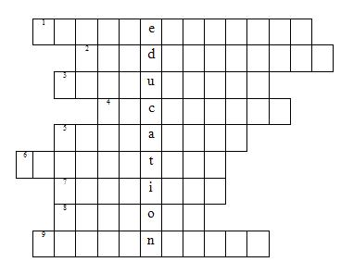
1) an adjective A state school for pupils ofdifferent abilities
2) a noun (amer) A school or class for young children aged 3-5 that prepares them for normal school
3) an adjective This word means obligatory
4) an adjective The educational teaching of children between the ages of 11 and 16(17)
5) a noun It’s a kind of school or a special room for doing physical exercises
6) an adjective Education for children between 5 and 11(primary in Britain)
7) a noun The universities of Oxford and Cambridge in one word
8) a noun A place where children learn(are taught)
9) a noun A spoken or written test of knowledge especially an important one

Lecture 14
American arts

Goal: to get acquainted with the history of arts in the USA
Students will be able:
1 to get some additional information about arts in the USA
2 to learn about famous artists, architects and musicians
3 to speak about their favourite American films, pop singers,actors and actresses

In the years following World War II, a group of young New York artists emerged with a fierce drive to remake the goals and methods of art. Their movement know as Abstract Expressionism.
America’s first well-known school of landscape painting – the Hudson River School – appeared in 1820s.
The Abstract Expressionists’ radical innovations in the 1940s and 1950s were matched by American sculptors.
The early 1960s saw the rise of Pop art. “Pop” was followed by “Op” – art based on the principles of optical illusions and perception.
Scottish and Irish ballads German folk-songs have been sung in America by many generations.
In the 19th century Negro lyric songs “blues” spread among the white population.
At the end of the 19th century the first symphonic orchestras were formed in the USA. At the turn of the centuries, the first opera house “Metropolitan Opera” was opened in New York.
At the same time a new truly American genre appeared – the musical.
In the 20th century another break took place in American music – jazz.
In 1954 the disc jockey Alan Freed started to broadcast the Negro rhythm-and-blues records. He called this music Rock-and-roll.
The American theater is over two hundred years old, but American drama became American only in the 20th century.
The centre of the US theatrical world is in a section of New York City and near Broadway.
Broadway is a wide avenue cutting though New York’s Manhattan Island as a diagonal.
As a reaction to the crisis in 1952 a new theatre was formed – the living theatre which produced experimental plays by new playwrights.
Off-Off-Broadway theatres perform in coffee-houses, offices, stores and even churches.
“Hollywood” is the name of a Los Angeles district which appeared in 1910, and it also stands for American cinematography.
One of the greatest events in Hollywood is the annual presentation of Oscar which is the highest Award of the American Cinema Academy.

Questions:
1What was the first American landscape painting school?
2Why was it called the Hudson River school?
3What type of music spread in the 19th century?

Tasks:
Be ready to talk about the following:
1.History of American painting.
2.The Hudson River school.
3.The Ash Can School.

Lecture 15
American Mass media

Goal: to give some basic information about mass media in the USA
Students will be able:
1 to learn such notions like “quality newspapers”, “tabloid newspapers”
2 to talk about famous American Broadcasting companies
Today the media include newspapers, pamphlets, books, radio, films, TV and cable TV.
The first regular newspaper was the Boston News-Letter.
In 1833 a young printer named Benjamin Day Launched the New York Sun the first American paper to sell for a penny.
The 1920s also saw the birth of a new mass media-networks-two owned by NBC (National Broadcasting Company), one by CBS (Columbia Broadcasting System).
TV became concentrated in three major networks – CBS, NBS and ABC (the American Broadcasting Company).

Questions:
1 What does the media include?
2What was the first regular newspaper?
3Who launched the first American paper to sell for a penny?
4What are the main major networks?

Tasks:
“True” or “False”
- In the United States adults average 25 percent of their time every day consuming mass media content.
- More homes in the United States have televisions than indoor plumbing.
- At the present levels of viewing, young American adults who live to age 65 will have spent two sold years just watching television.
- The three top television anchors, Tom Brokaw of NBC, Peter Jennings of ABC and Dan Rather of CBS each make about $2 million a year.
- The average starting salary for a weekly newspaper reporter or a television broadcaster in the United States is $10 per hour.
- About 42-percent of the 1500 largest corporations in the US have public relations departments.
- Newspaper are the primary source of news for most Americans.
- There are about 1 million newspaper carriers in the United States.
- Americans average about 30 minutes a day listening to the radio.
- So many magazines have failed since the advent of television that fewer than 3000 are left in the United States.

References:

1. Tomakhin G.D. Countries of the United Kingdom. Moscow, 2001
2. Nesterchuk G.V., Ivanova V. M. The USA and the Americans.Minsk, 1998
3. Tokareva N.D. Pages of history: Glimpses of Britain and the USA. Moscow, 1985
4. ПавлоцкийВ.М. American studies. Saint - Petersburg, 2002
5. Khalilova L.A. The USA: History and the present. Moscow, 1999
6. Письменная О.А. Окна в англоязычный мир. Москва, 2004
7. Нестерова Н.М. Страноведение: Англия. Ростов-на-Дону, 2001
8.ShpotovaB.M. An outline of American history. Moscow, 1993
9.Томахин Г.Д. По странам изучаемого языка. М., 1978.
10.Нестерова Н.М. Страноведение: Англия. Ростов-на-Дону, 2001.
11.Березная Н.А., Долгоруков А.П., Дроздов Н.У., и др. Великобритания. М., 1990.
12.О Британии вкратце. (Составители:В.В. Ощепкова, И.И. Шустилова).М., 1997.
13.Тимановская Н.А. Взгляд на Британию. Тула, 1996.
14.Города и графства. (Сост. Г.Д. Томахин). М., 2001.
15.Великобритания. Лингвострановедческийсловарь. М., 1978.
16.Кауфман К.И., Кауфман М.Ю. Страницы Британской истории. Обнинск: Титул, 2001.
17.Усова Г.С. История Англии. Санкт-Петербург, 1999.
18.A Glimpse of English Speaking Countries. (Составители:Е.Л. Власова, В.С. Грин и др.) М., 1969.
19.Британия. (Составители:Куприянова В.З., Арнольд И.В., Боровик М.А., и др.).Л., 1977.
20.История, география и культура Англии. (Под общей редакцией В.С. Кузнецовой), Киев, 1976.
21.Барбарига А.А. В школах Англии. М., 1988.
22.Барбарига А.А., Федорова Н.В. Британские университеты. М., 1979.
23.Федорова Н.В. Обсуждаем проблемы образования. Пособие по страноведении Великобритании. М., 1987.
24.Кроль А.Е. Английская живопись. Каталог. Л., 1969.
25.Alexis de Tocqueville. Democracy in America.New York, 1990.
26.An outline of American History. (Краткаяистория США) The United States Information Agency.Москва, 1993.
27.Dave Barry. Slept here.A sort of History of the United States.New York, 1989.
28.Edited by Allen F.Davis., Harold P.Woodman. Conflict and Concensus in Fairy American History, 1988.
29.Edited by Laidlaw Brothers. The Challenge of Freedom.Publishers, 1982.
30.Edited by Luther S.Luedtke. Making America.The Society and Culture of the United States. Washington, D.C., 1991.
31.Khalilova Lyudmila. The USA: History and the present. M., 1999.
32.MaxZeuke. A Short History of the United States of America.Leipzig, 1987.
33.Melvin I. Urofsky. Basic readings in U.S.Democracy.WashingtonD.C., 1995.
34.Tomakhin G.D. Across the countries of the English Language. Moscow, 1998.
35.Valilevich N.A. Reading Politics.Minsk, 1985.
36.ГолицынскийЮ.Б.TheUnitesStatesofAmerica. Санкт-Петербург, 2002.
37.Нестерчук Г.В., Иванова В.М. The USA and the Americans. Минск, 1998.
38.Павлоцкий В.М. American studies.М., 1997.
39.Составители Власова В.С., Грин В.С. и др. A glimpse of English speaking countries.
40.http://www.study-english.com.ua/usa-population/

